EE6045 MATLAB Assignment

## Question i)

1. cap_p = 1/100; % Set percentage of mismatch to apply

2. randn('seed', 31232); % Set random number seed

3. mismatch = randn(1,Nbit)*cap_p; % Create array of random offsets to apply to caps

4. Vcdac = Vcdac.*(1+mismatch); % Apply mismatch to capacitor vals (proportional to size)

5.

## Question ii)

Transfer Function

Capacitor mismatch **p = 0 %**

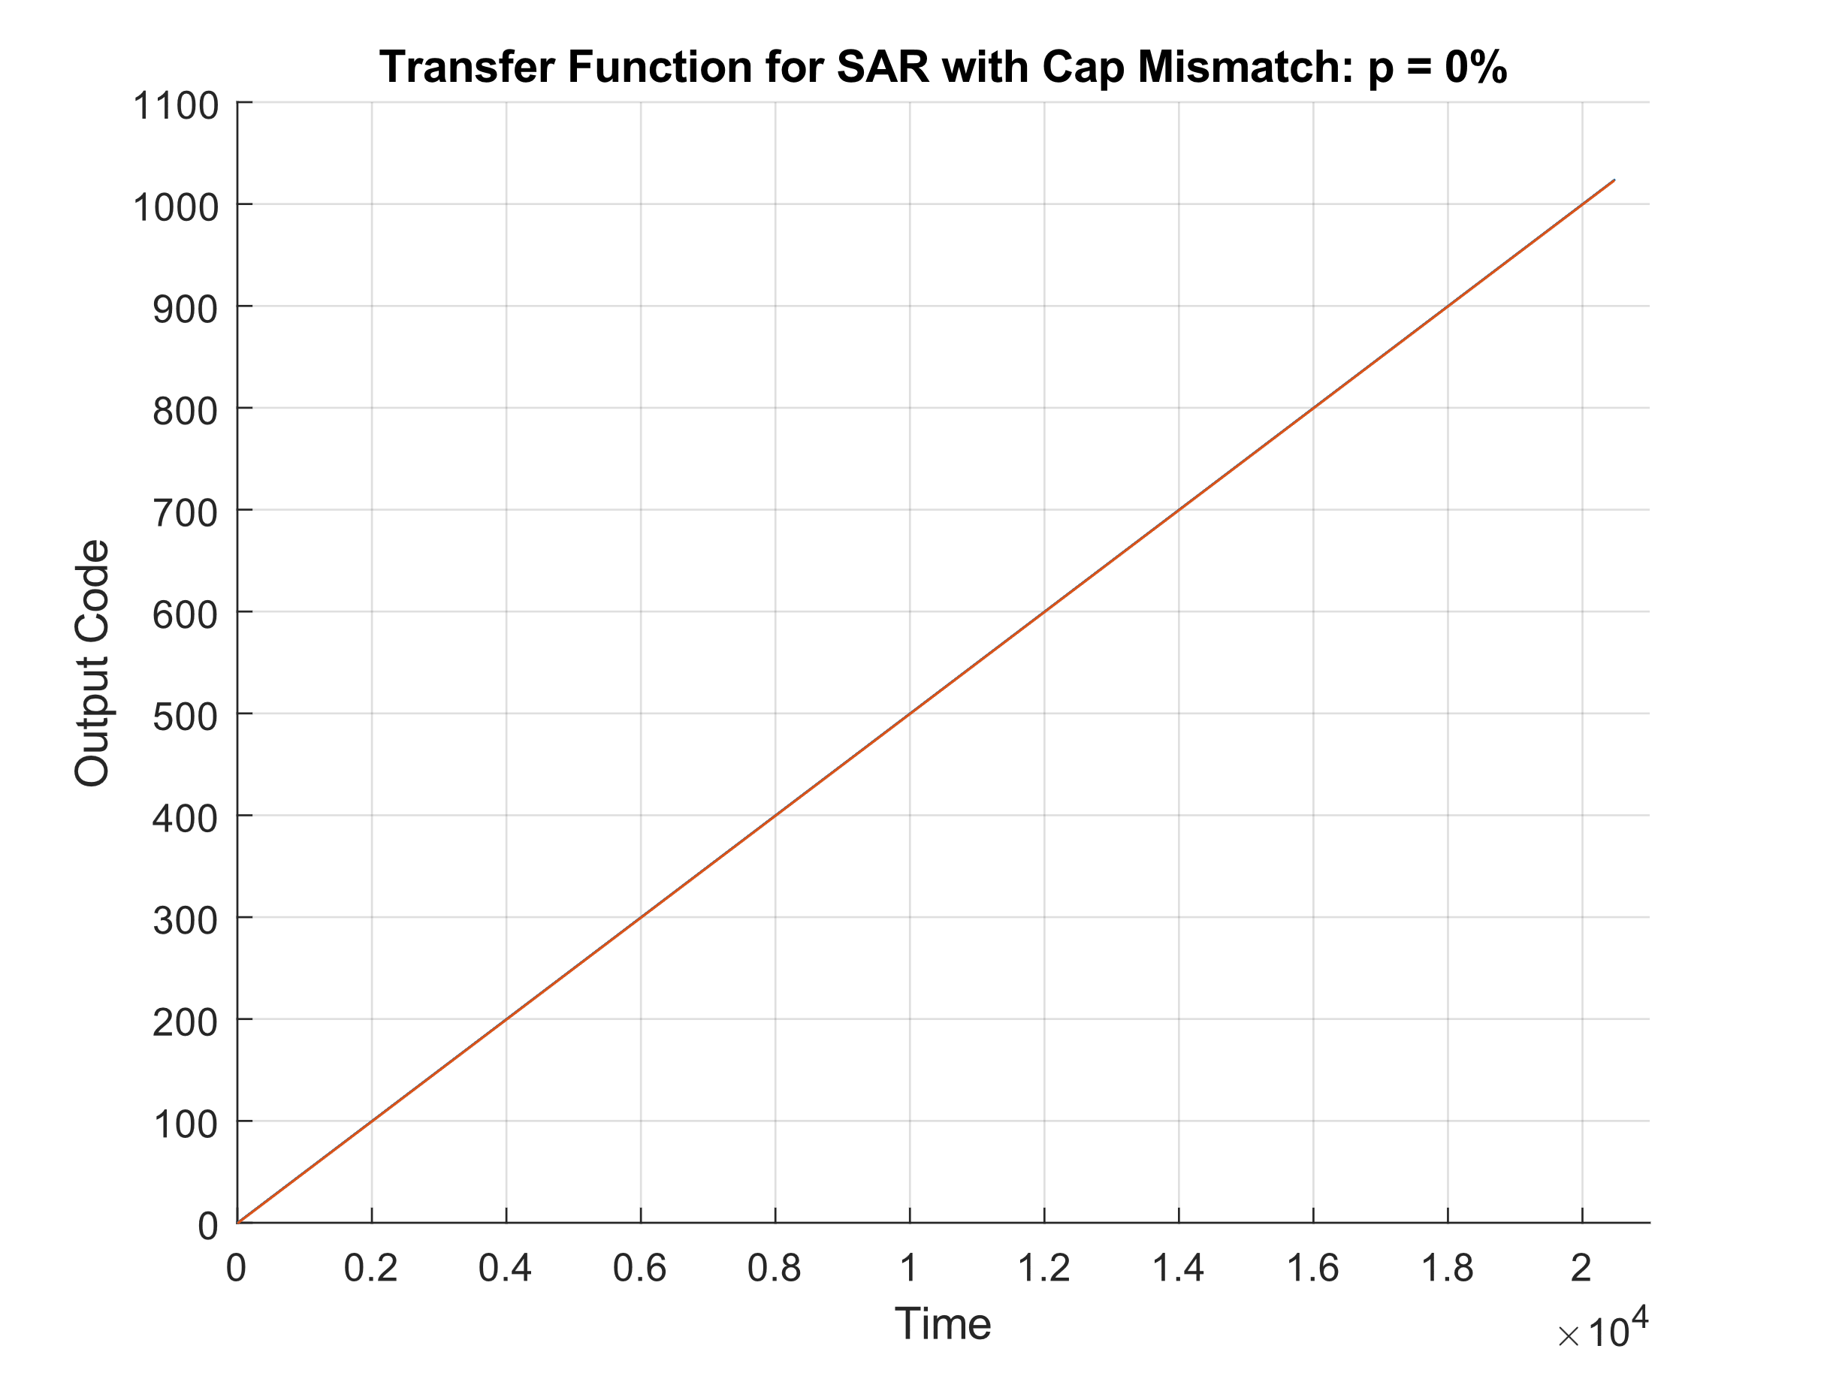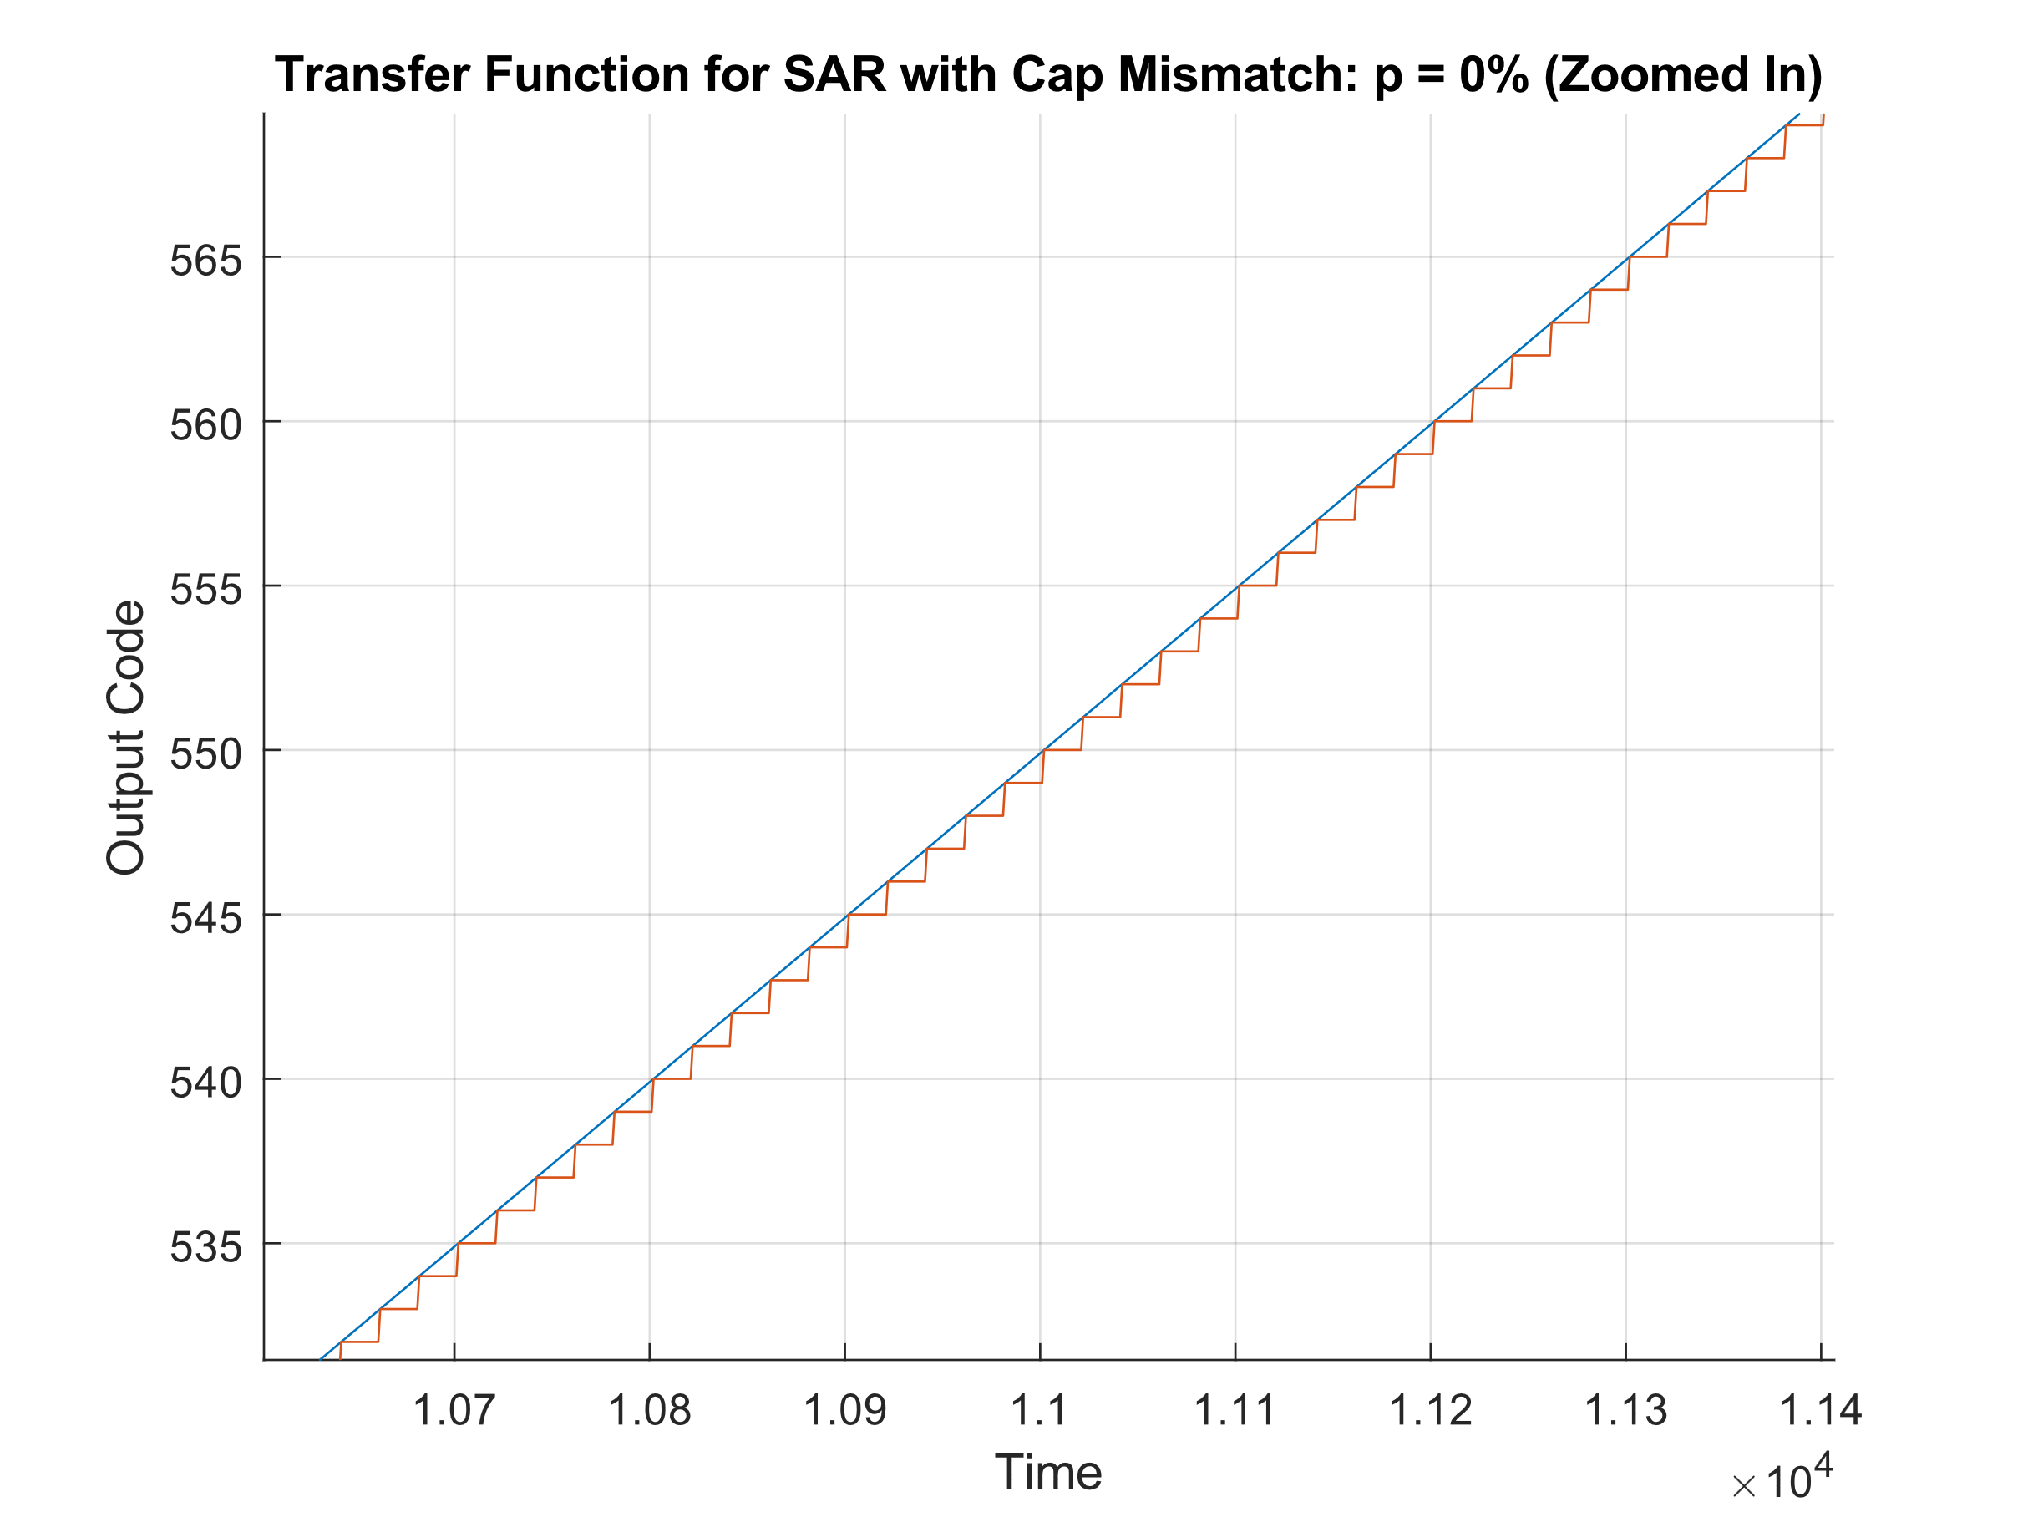

Capacitor mismatch **p = 0.1** **%**

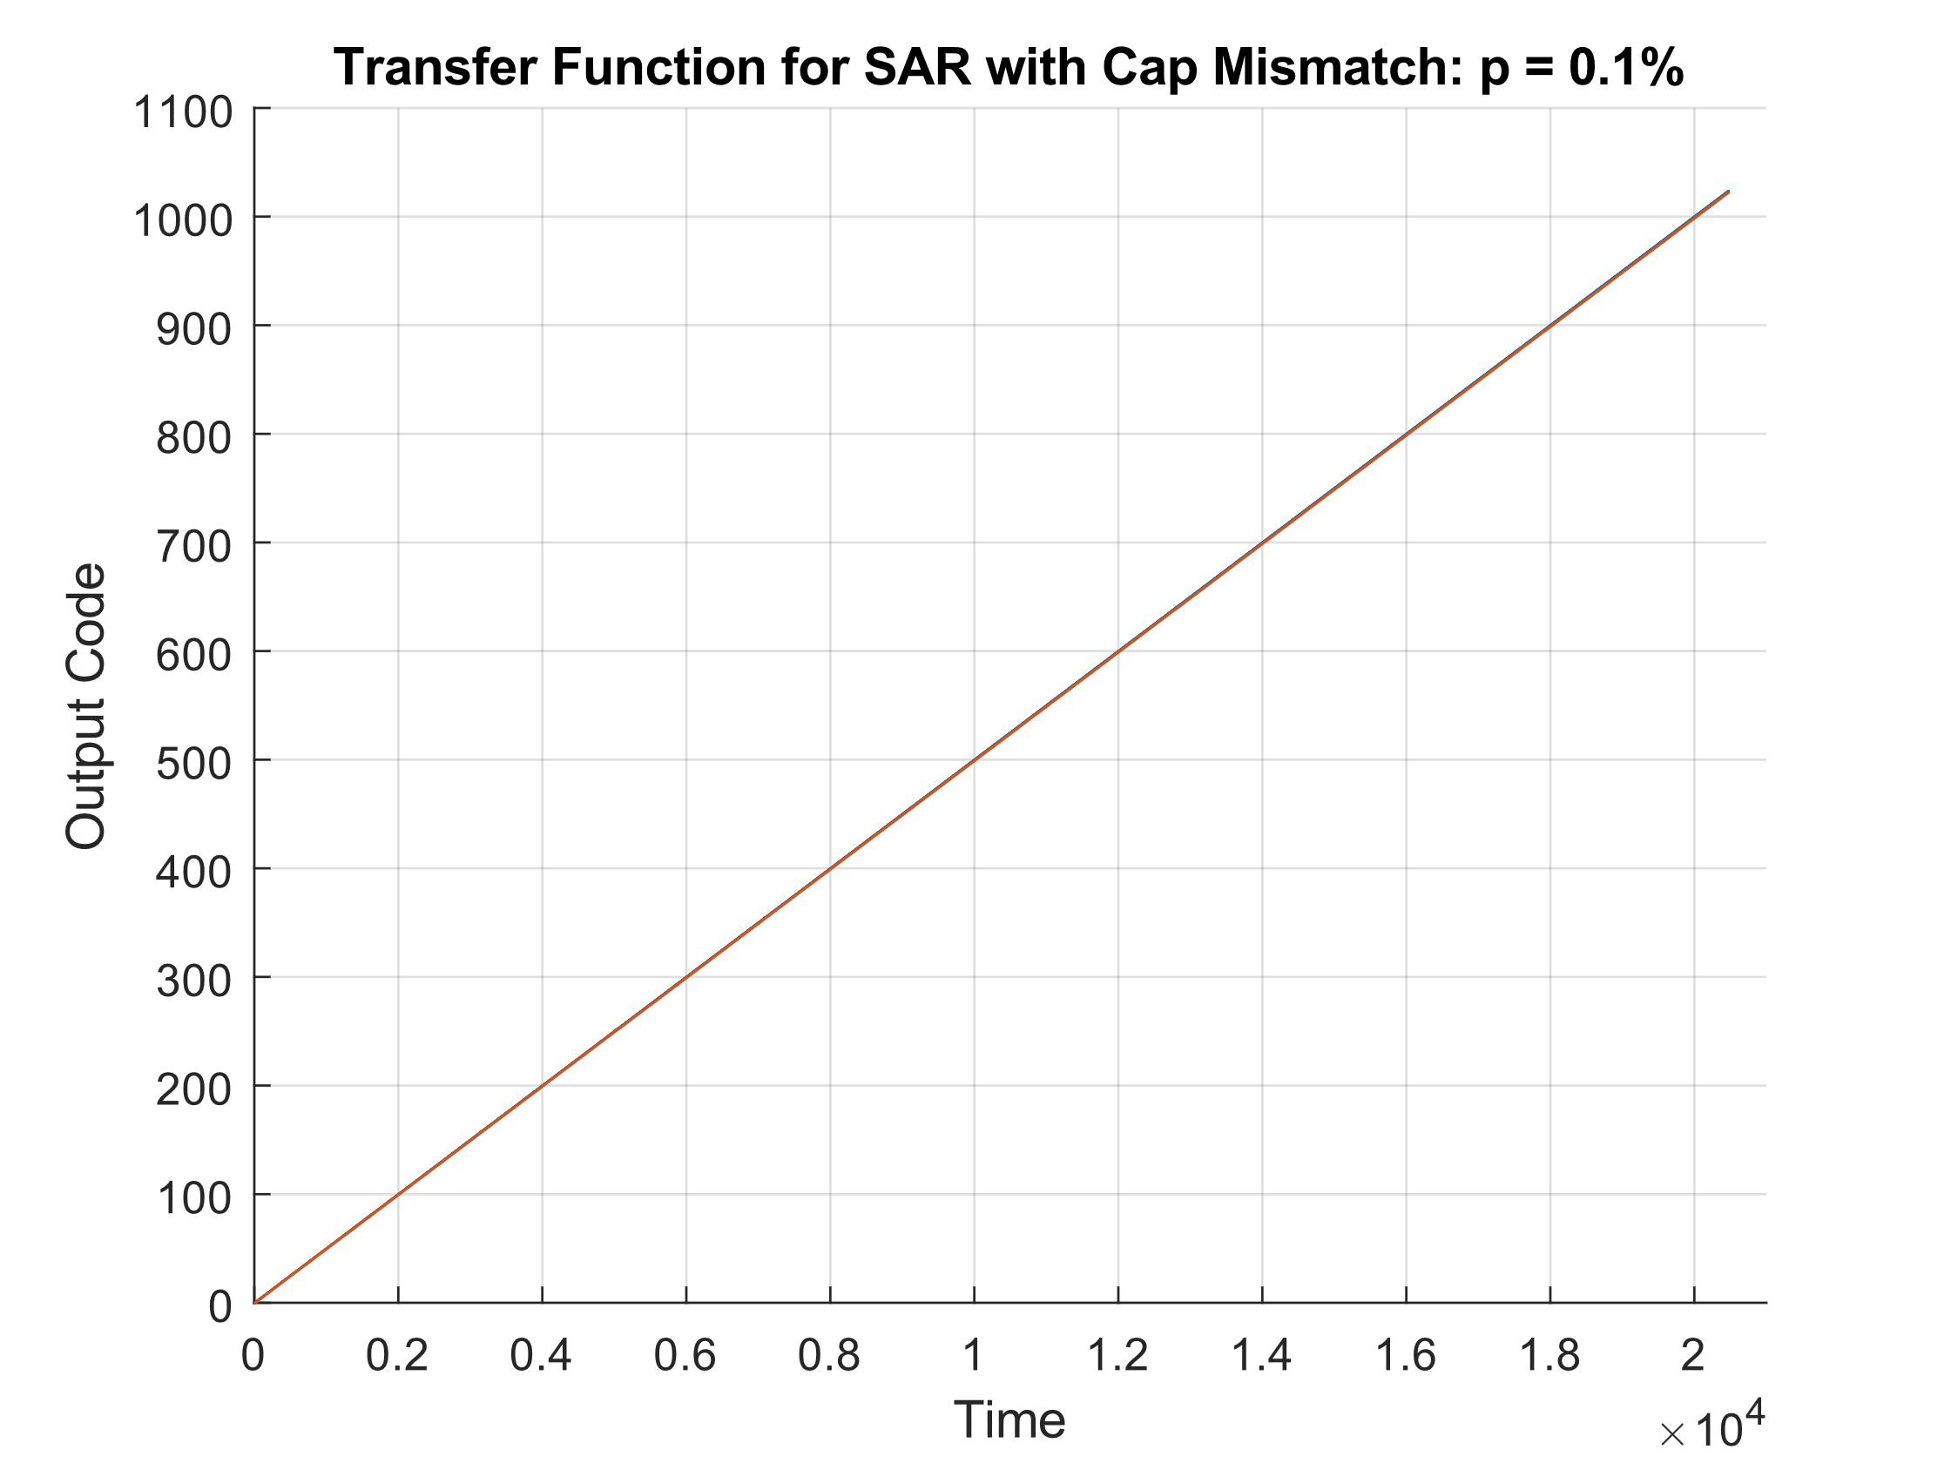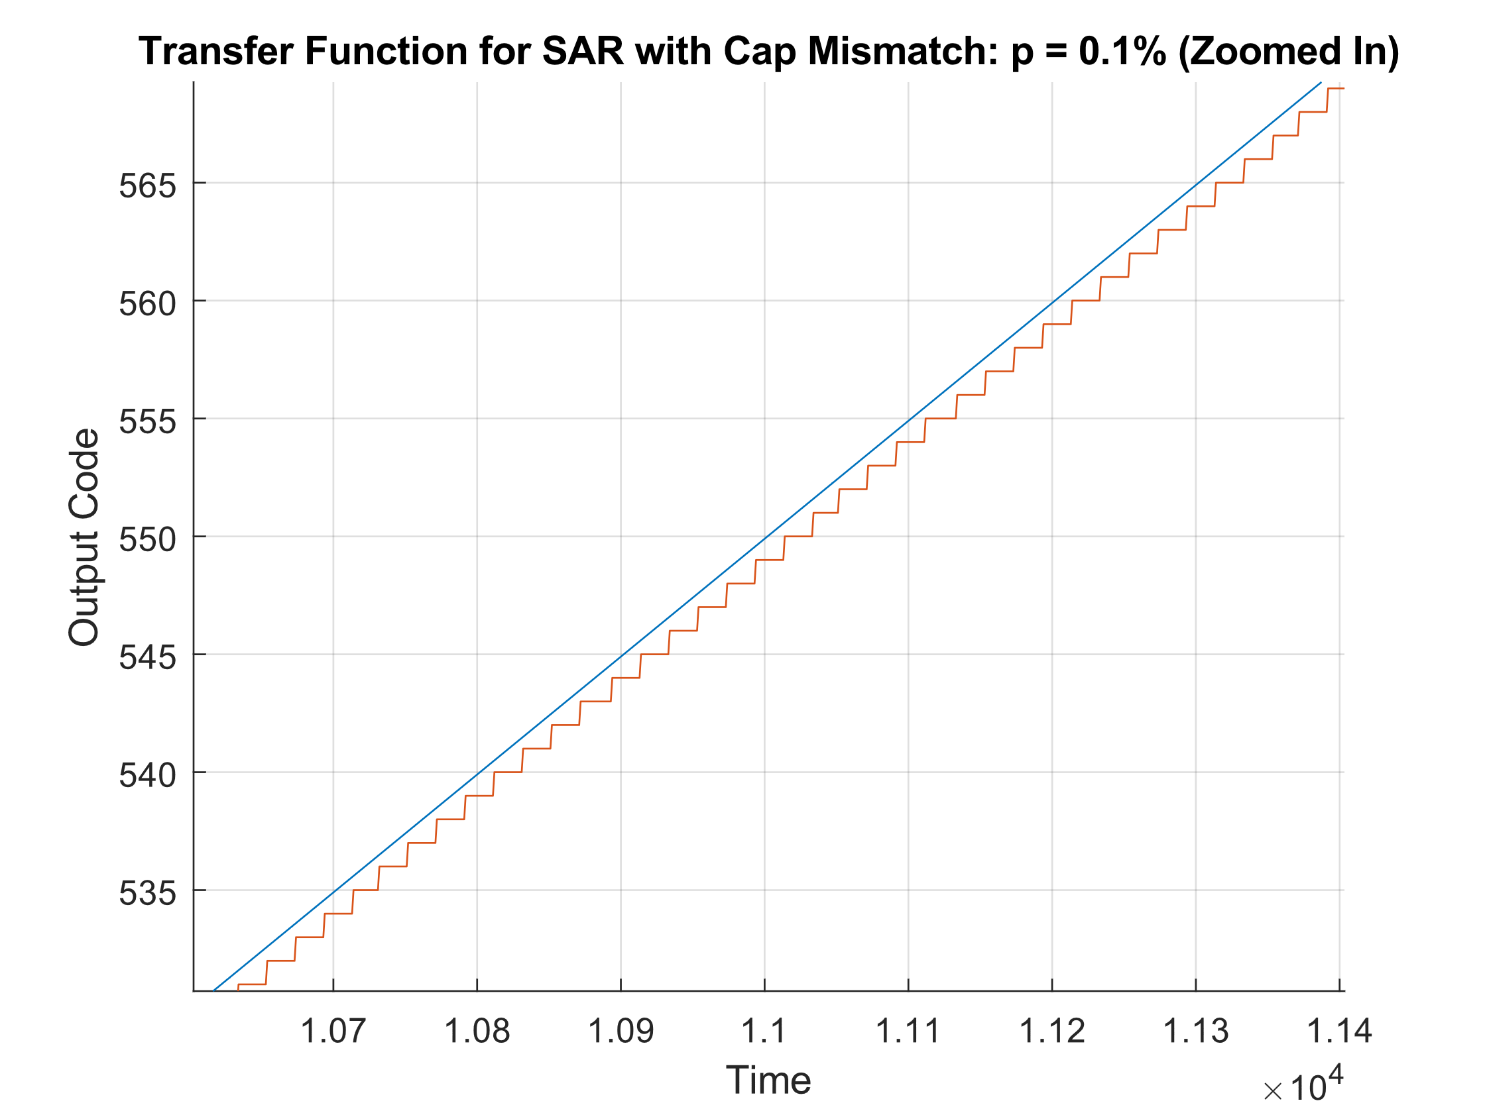

Capacitor mismatch **p = 1 %**

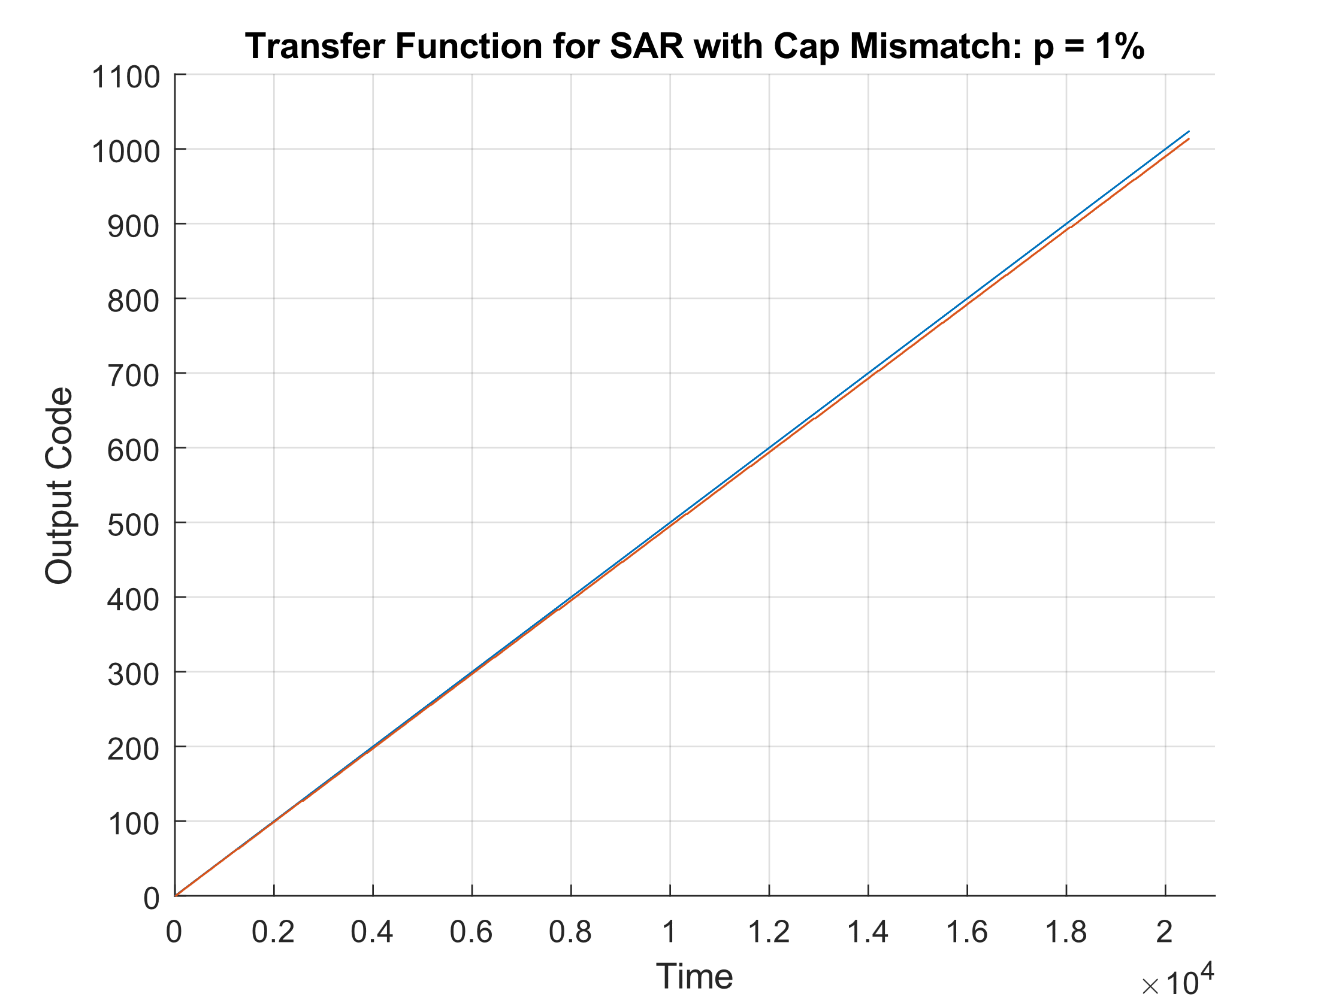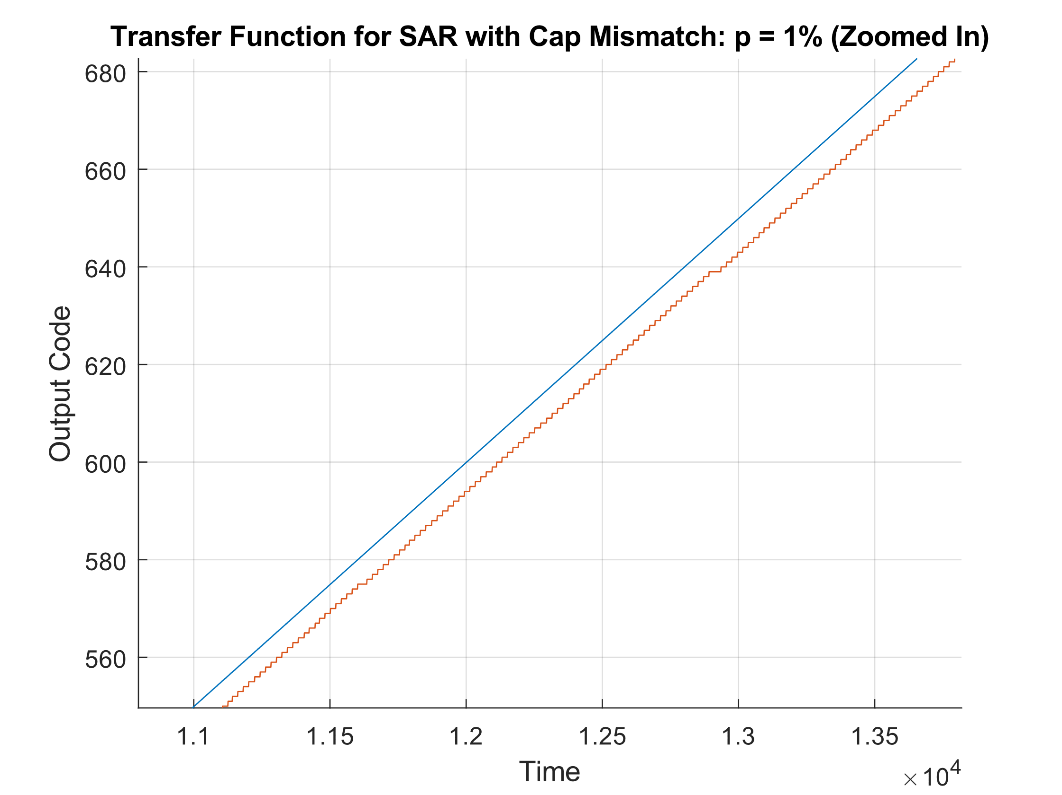

Spectrum, ENOB, SNR

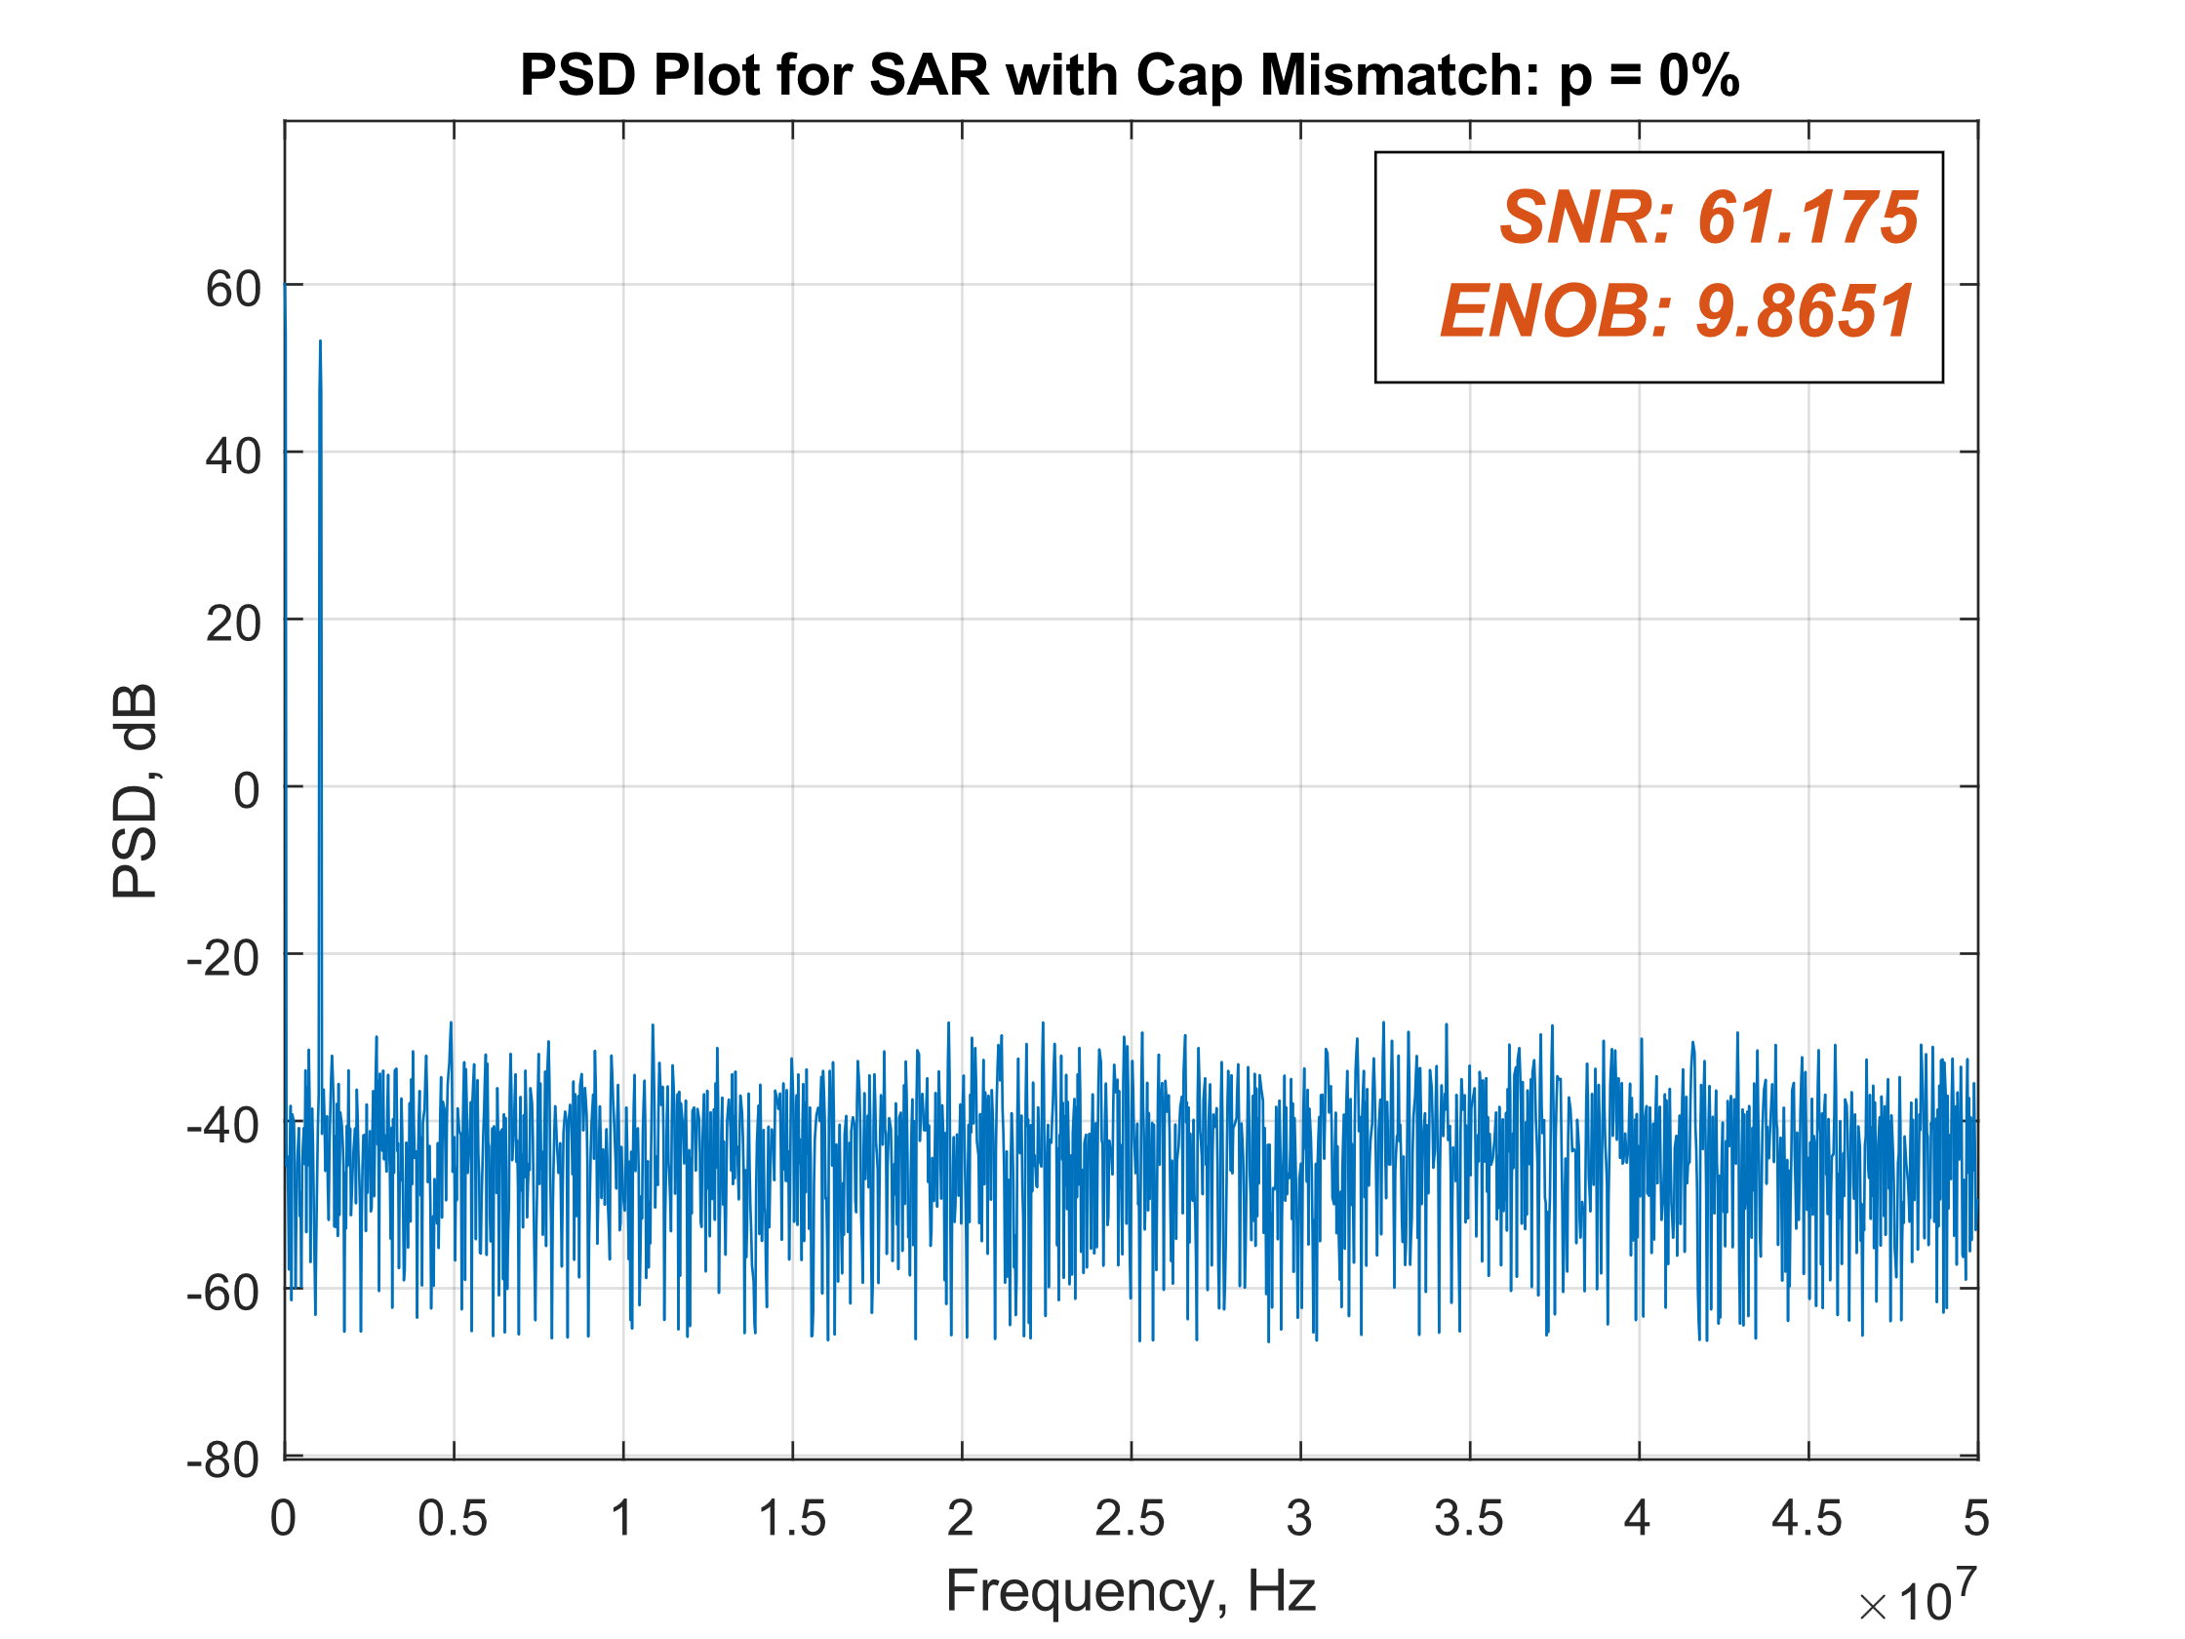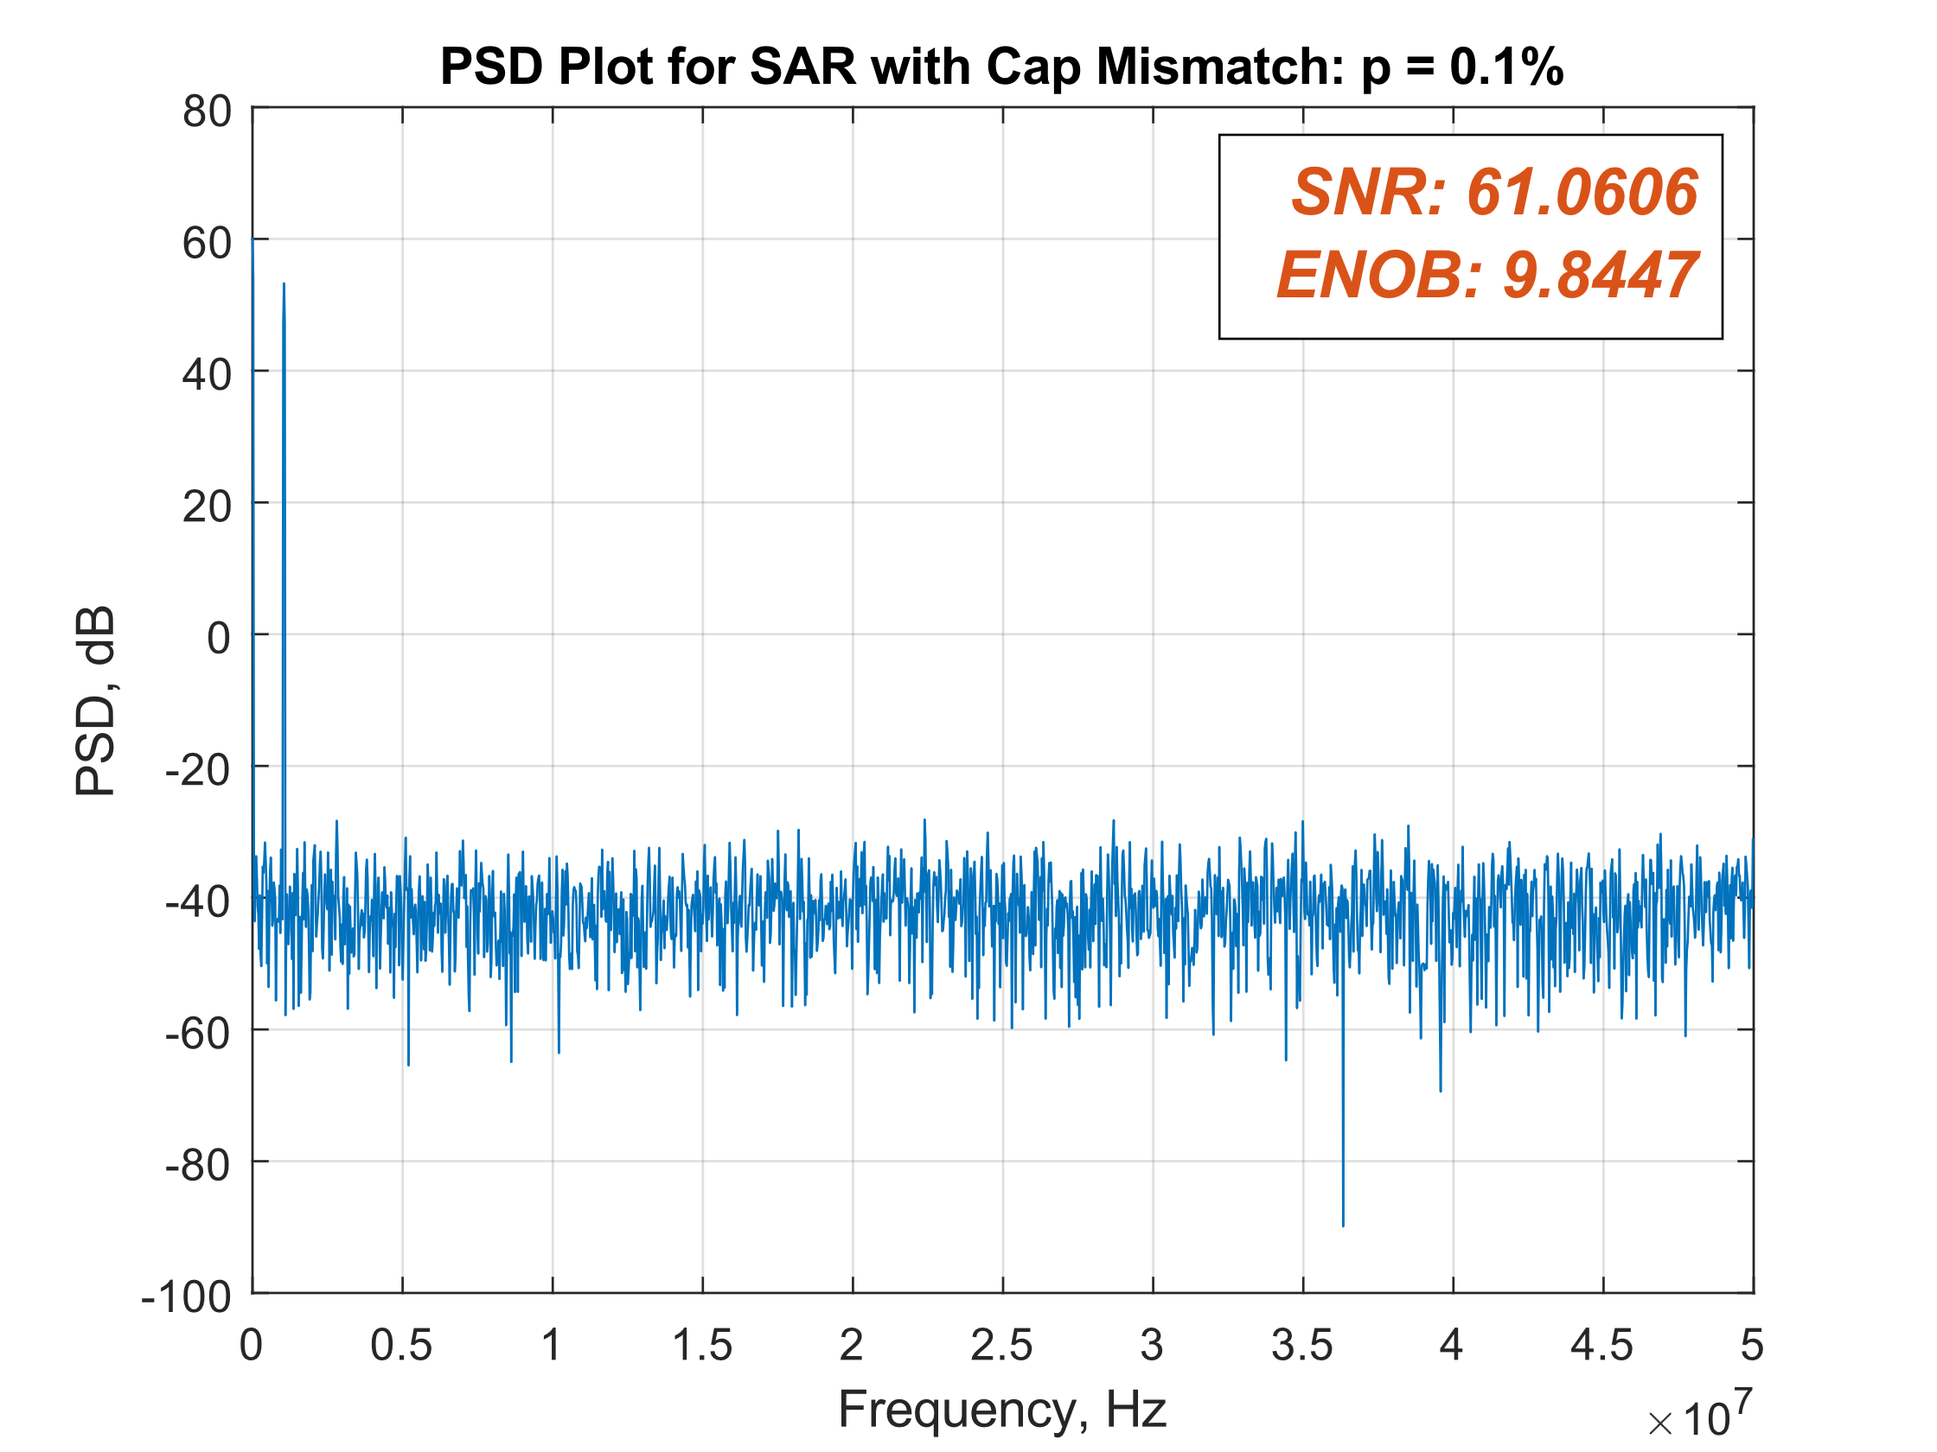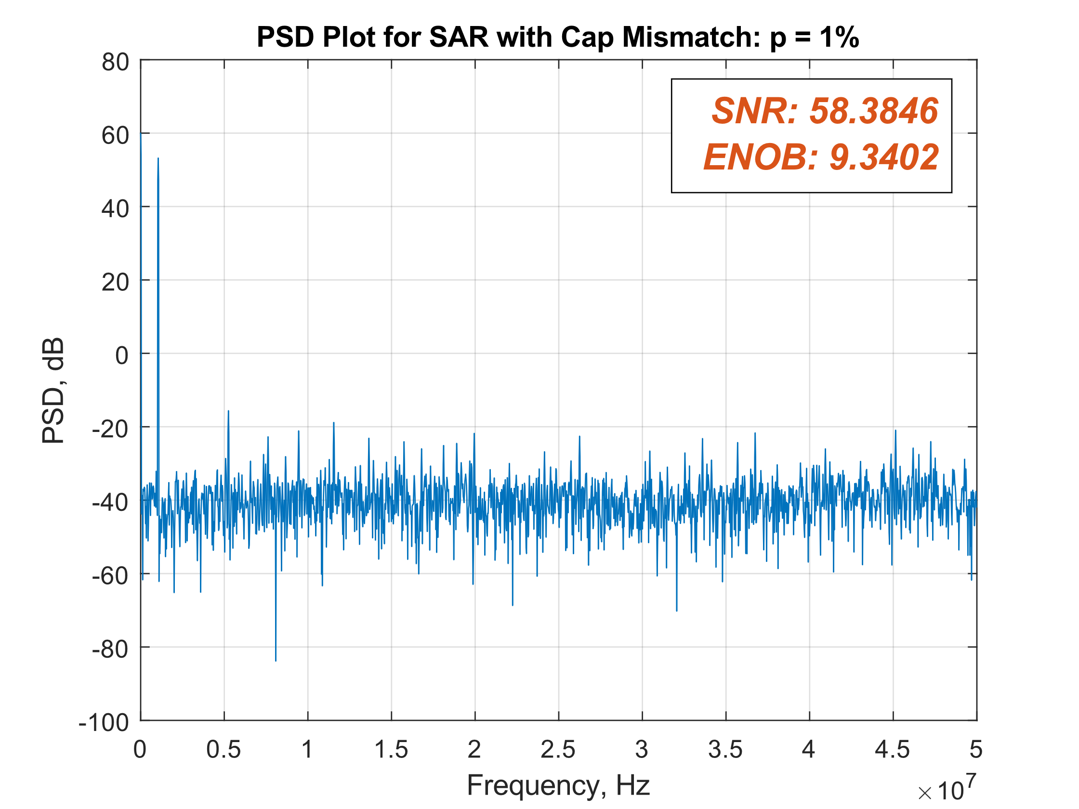

INL/DNL

Capacitor mismatch **p = 0%**

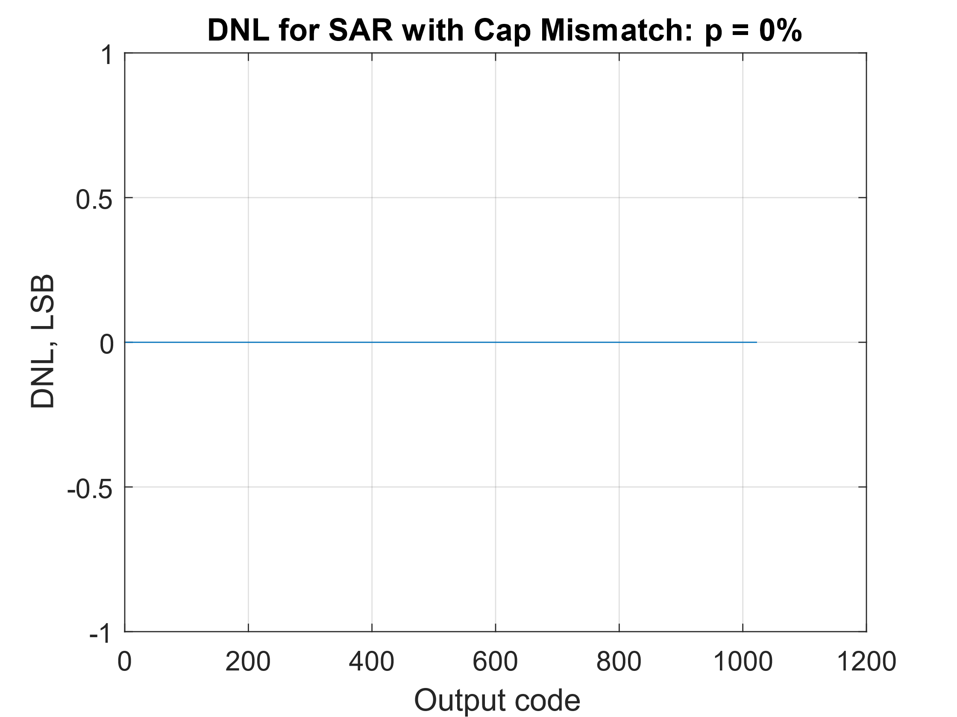 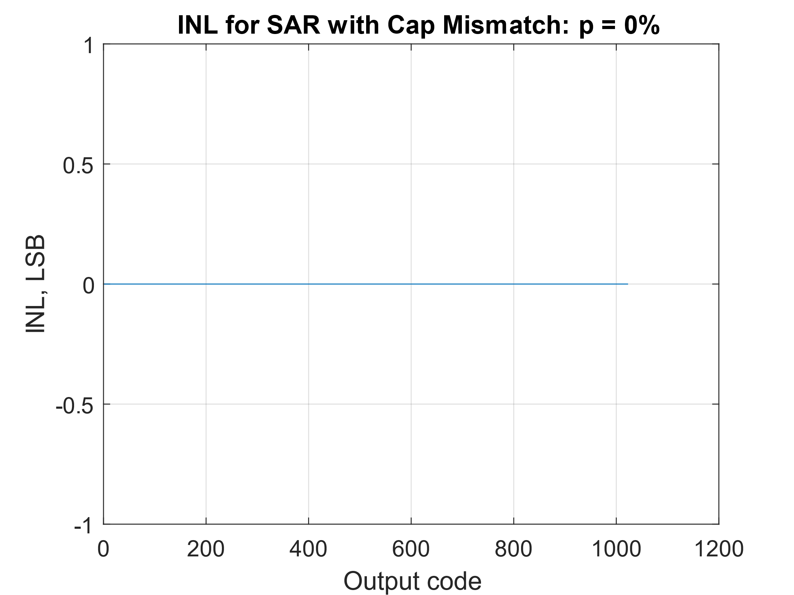

Capacitor mismatch **p = 0.1%**

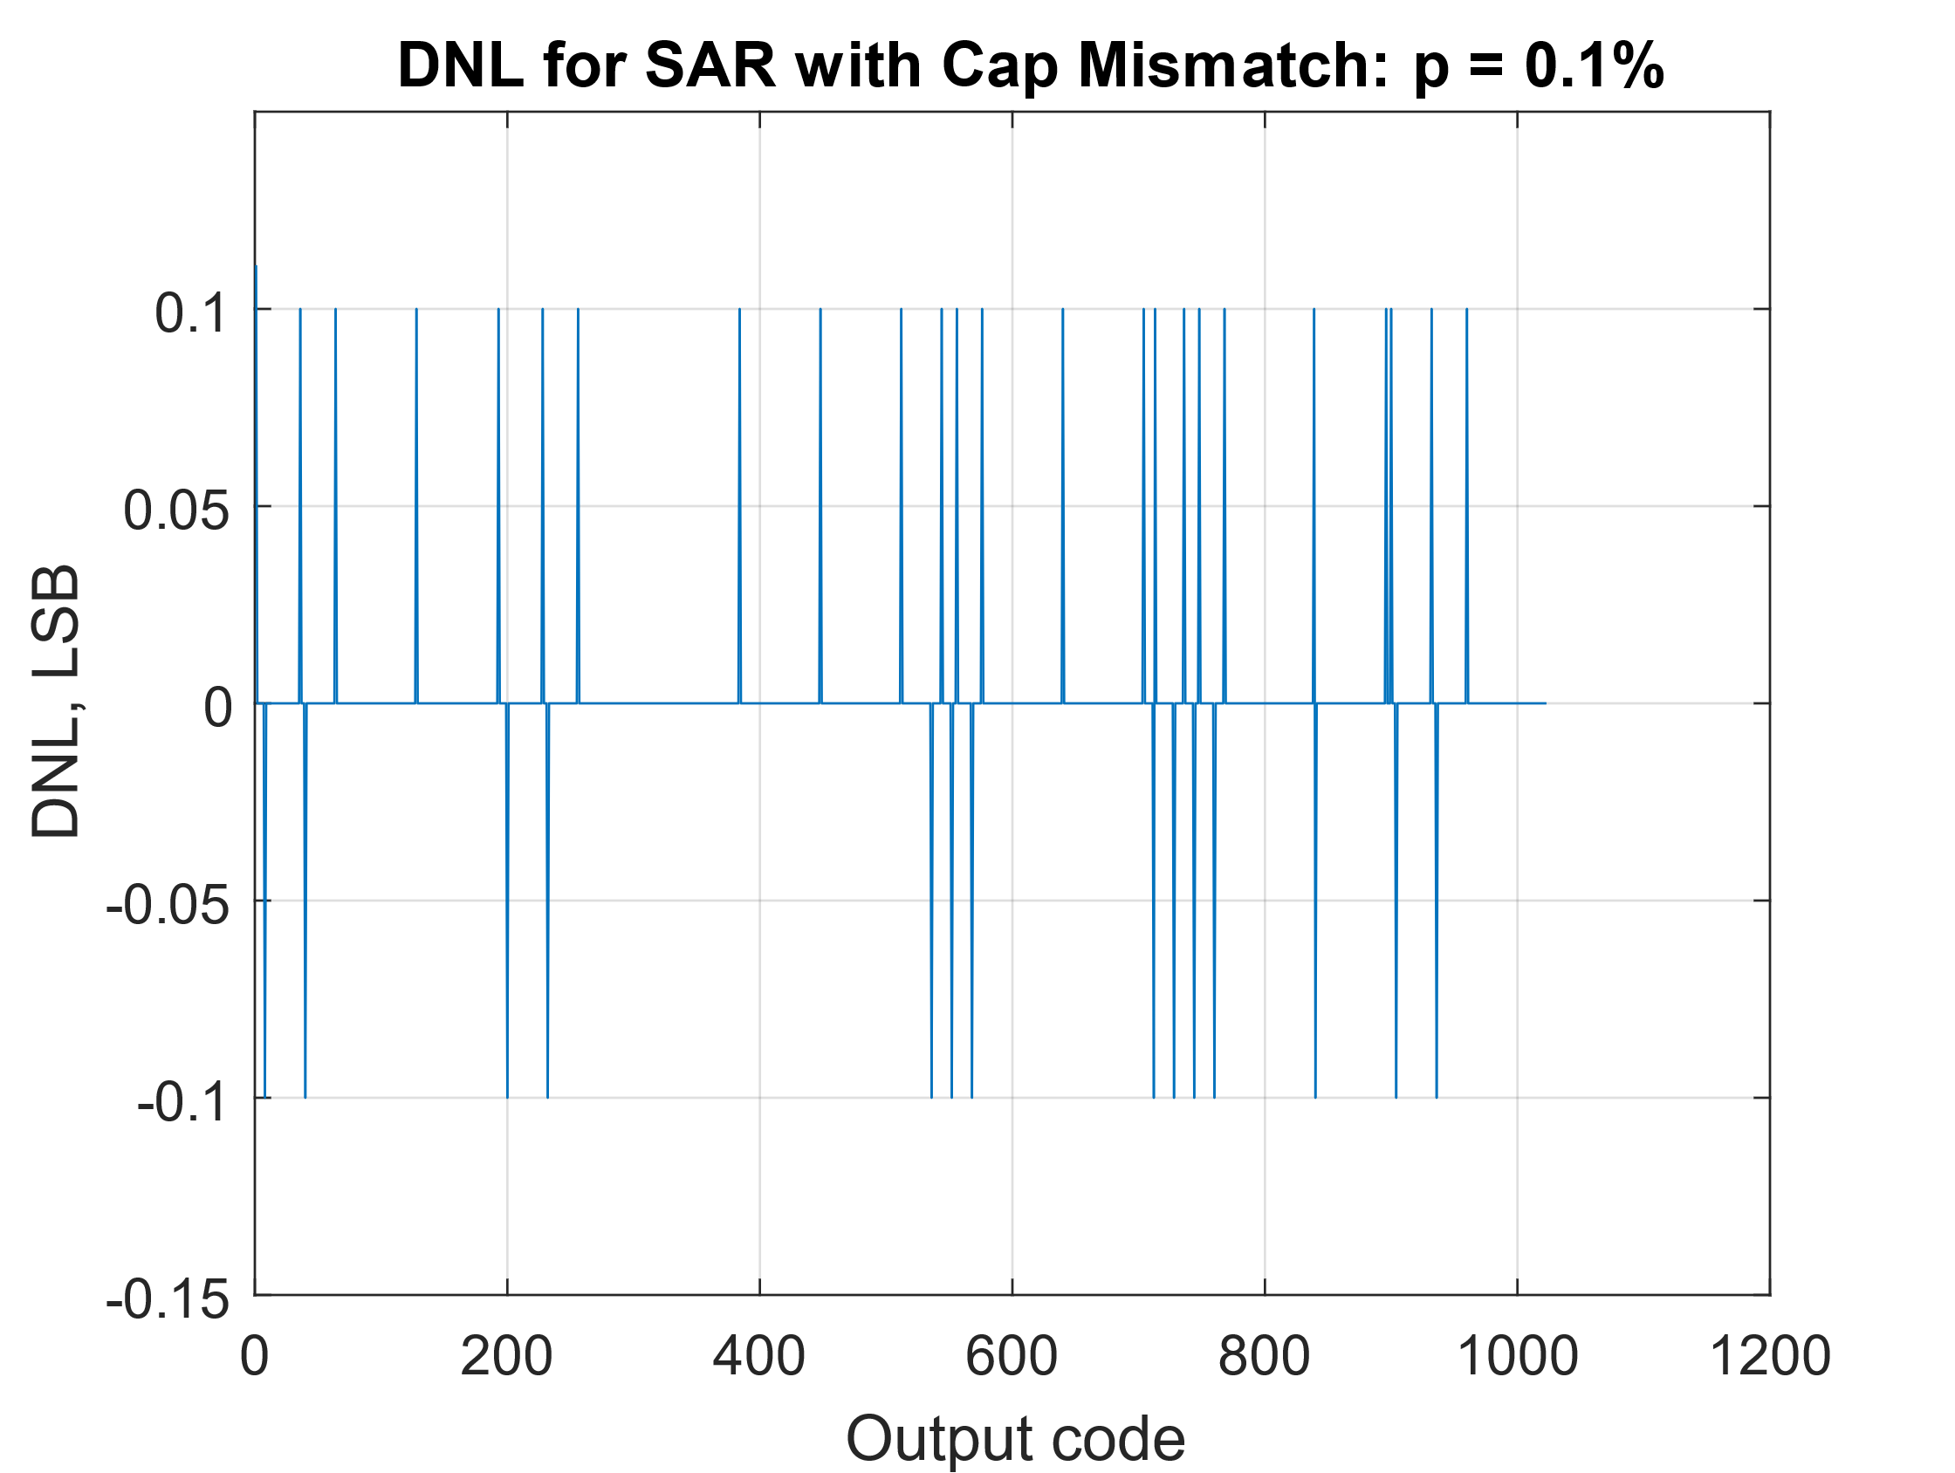 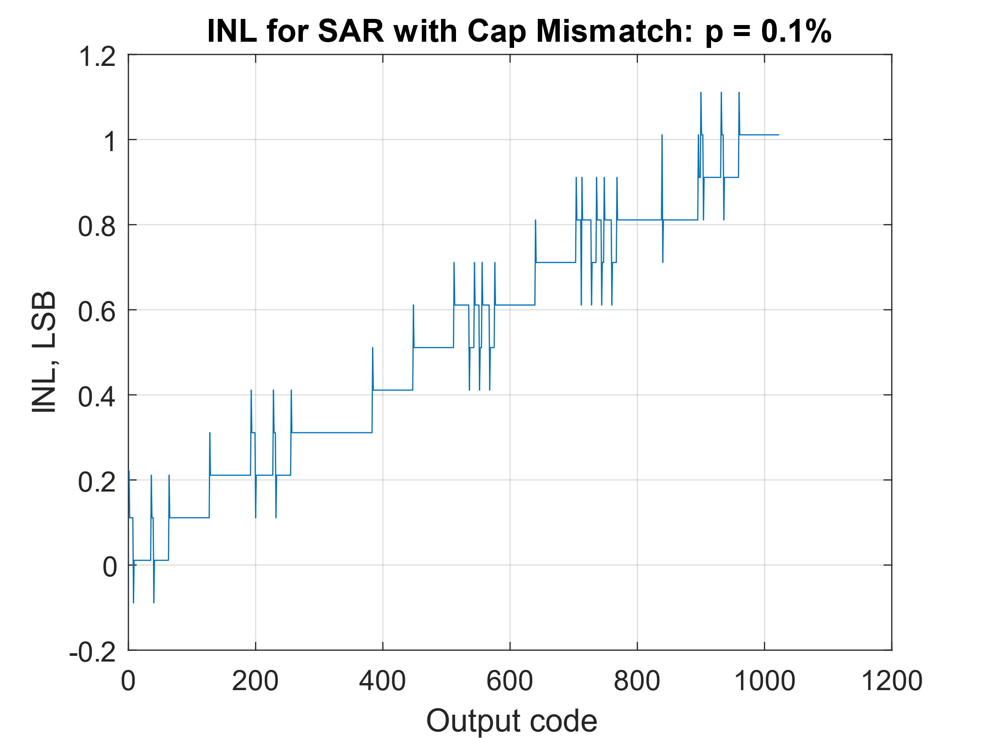

Capacitor mismatch **p = 1%**

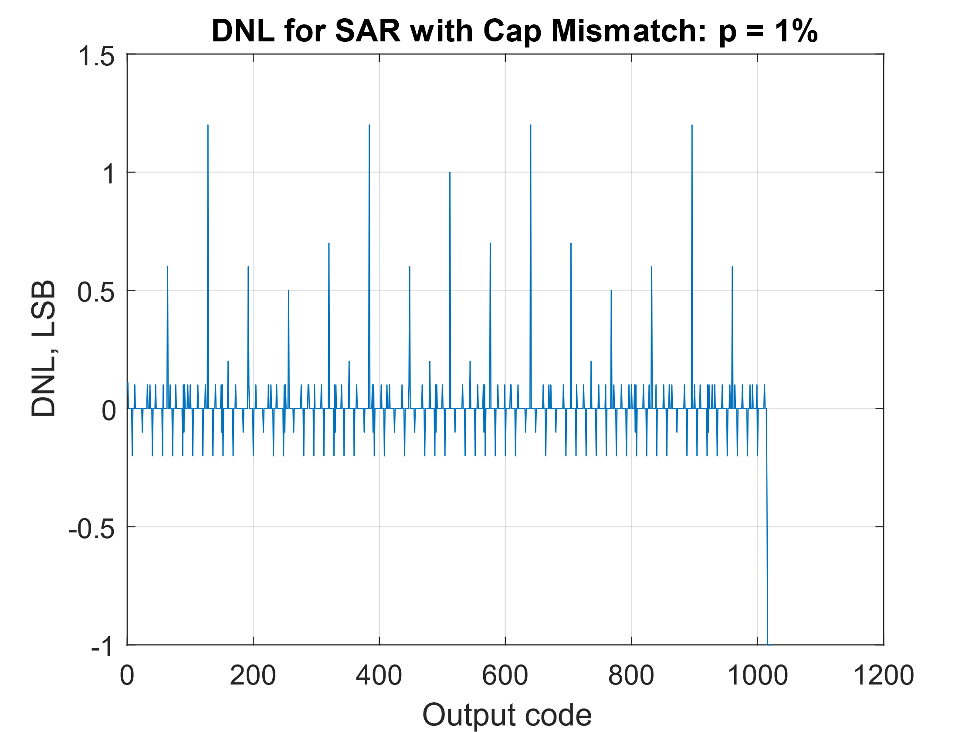 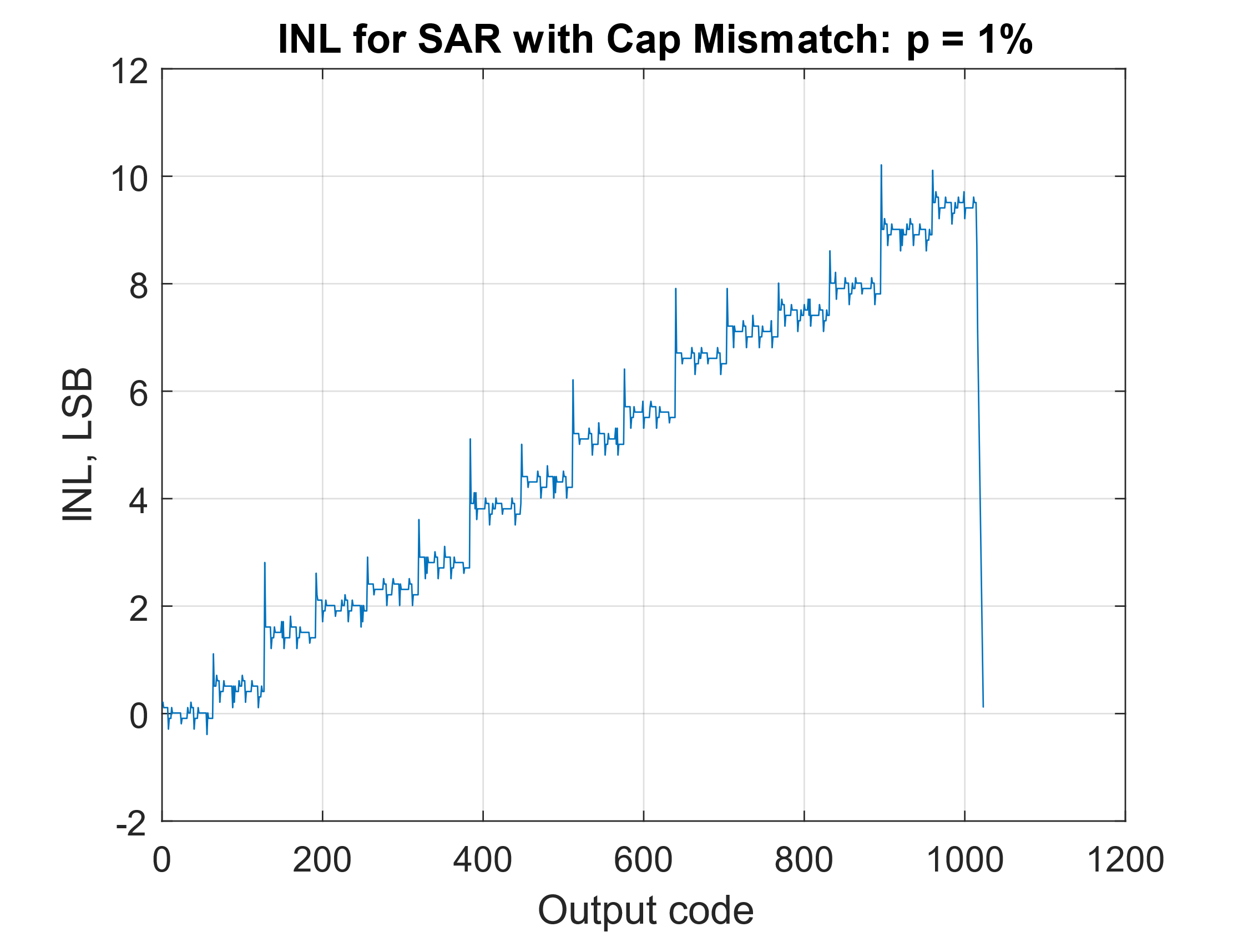

How does SAR ADC compare to Flash – (compare to flash performance in Lab 2 Manual)

* Which one is more robust to mismatch
* Maximum mismatch to get 0.5LSB DNL/INL

## Question iii)

DNL/INL

Comparator mismatch **p = 0.1%**

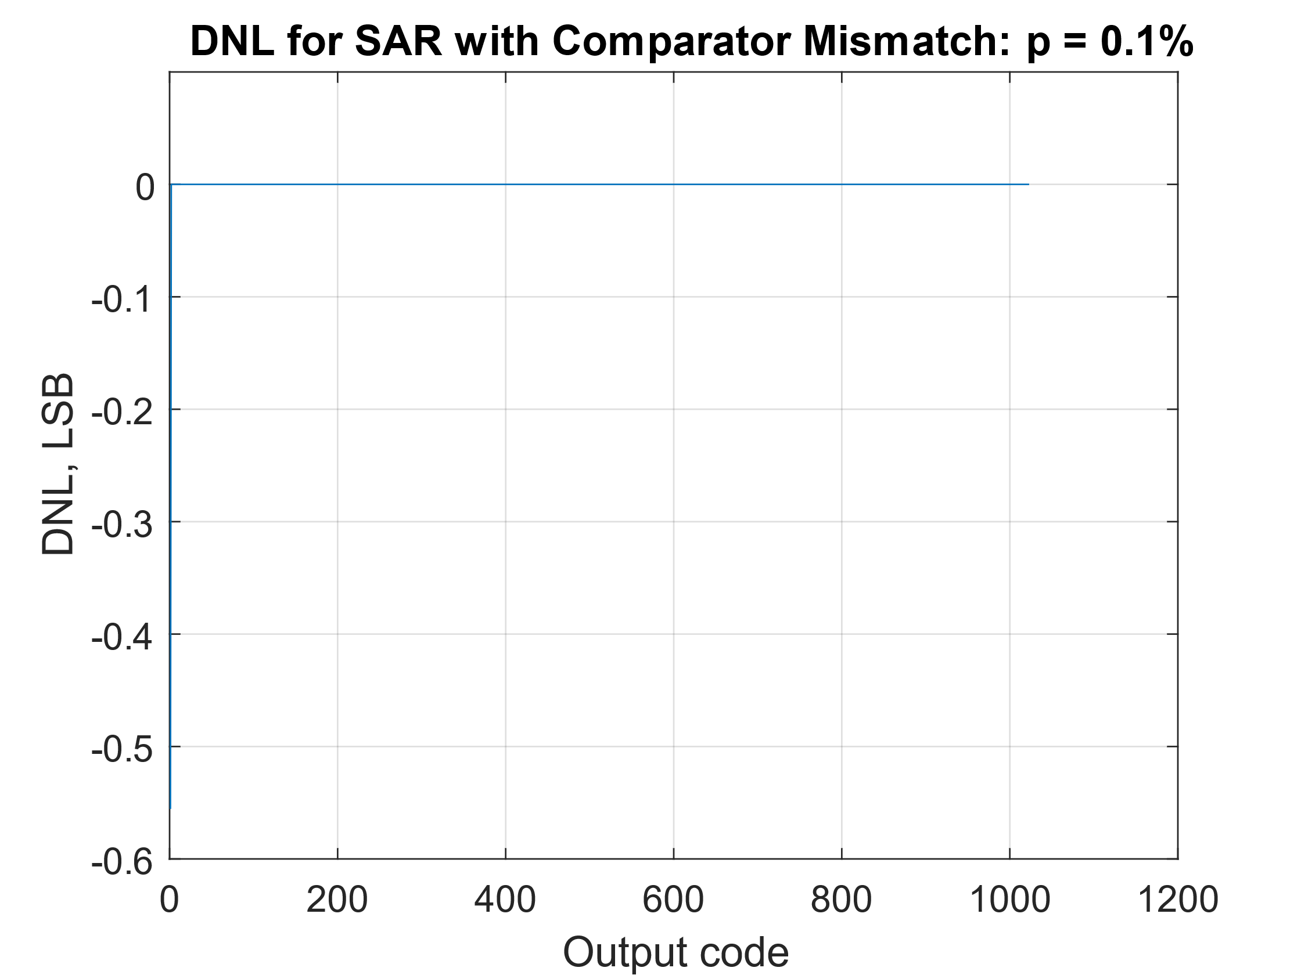 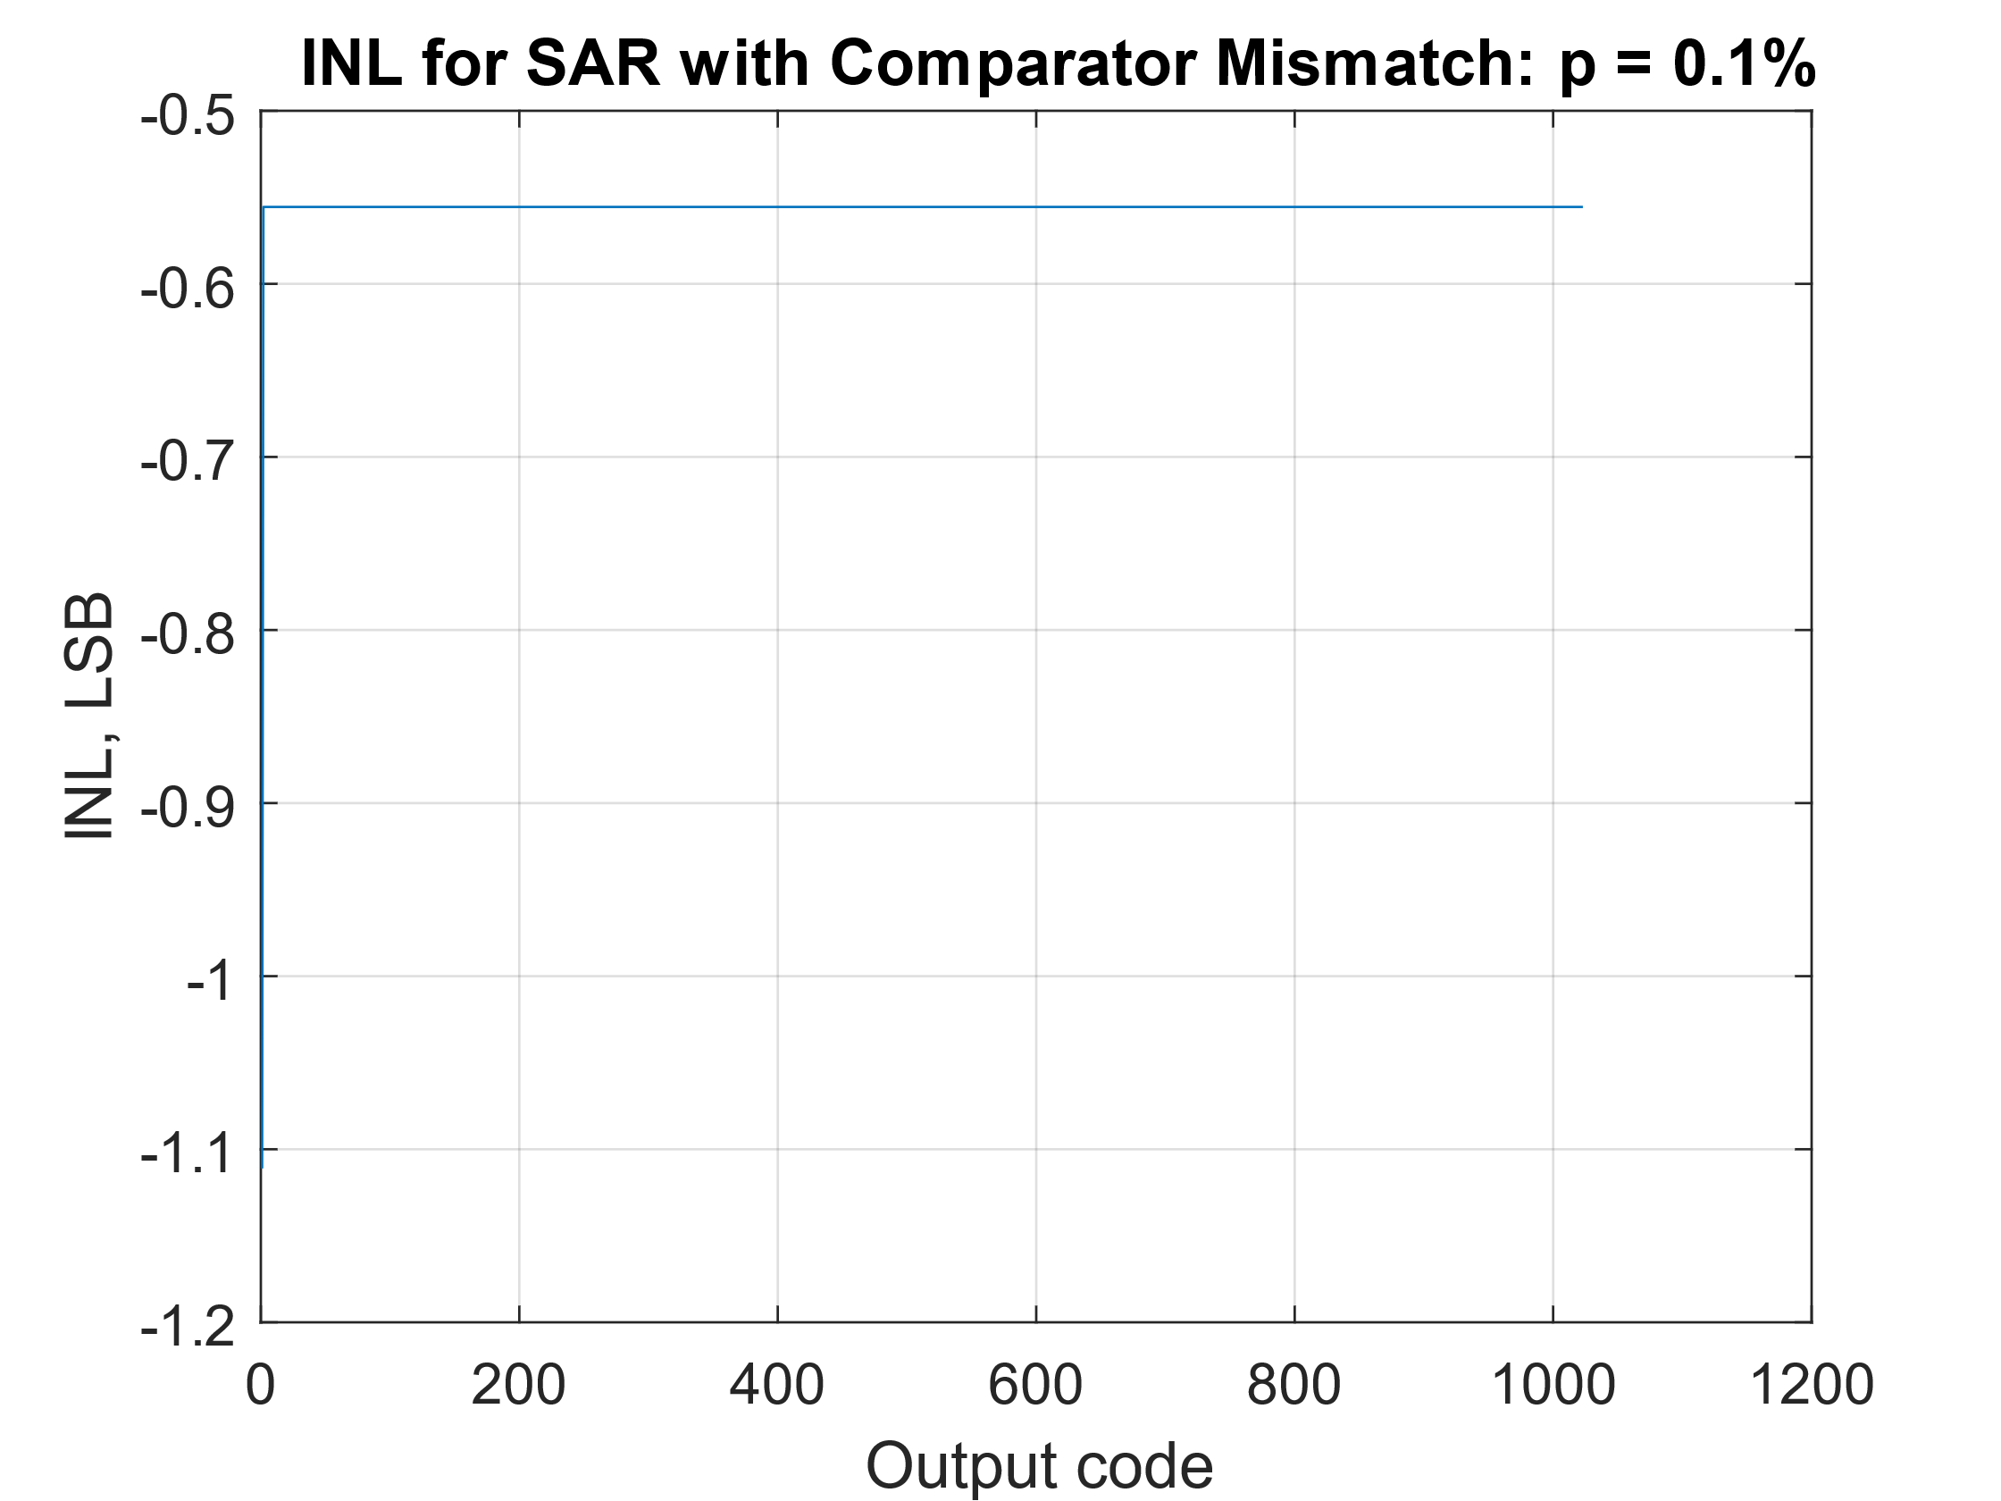

Comparator mismatch **p = 1%**

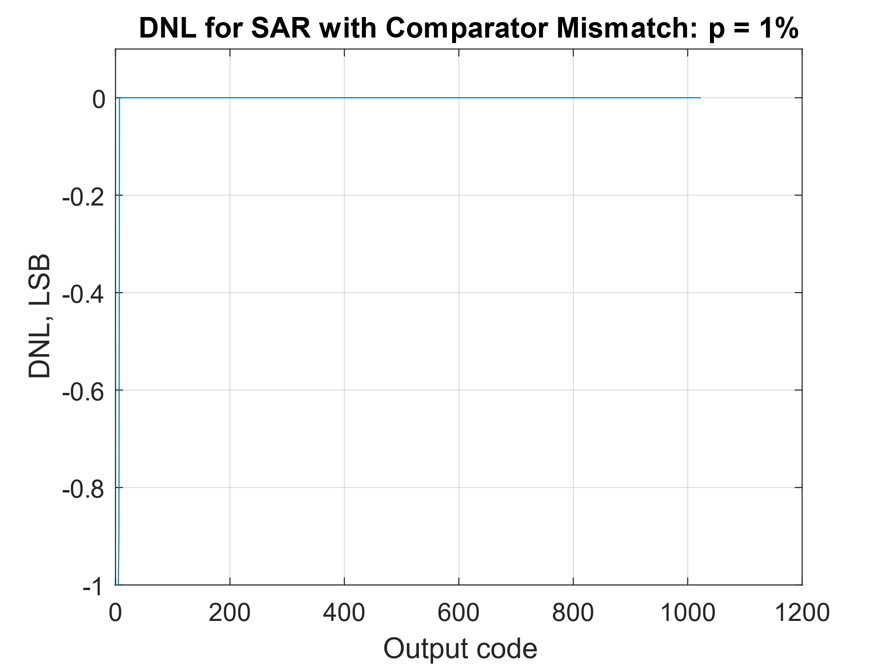 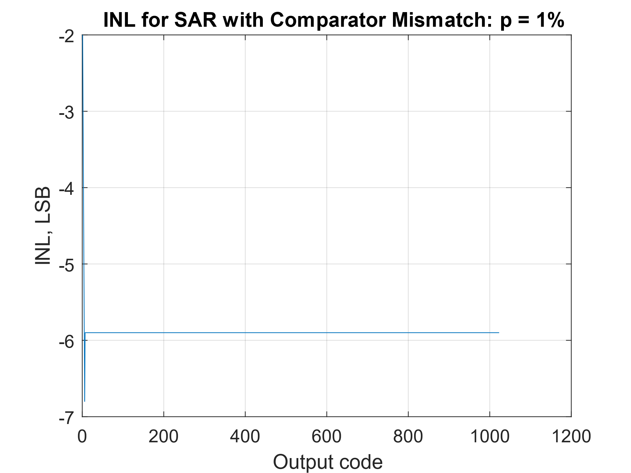

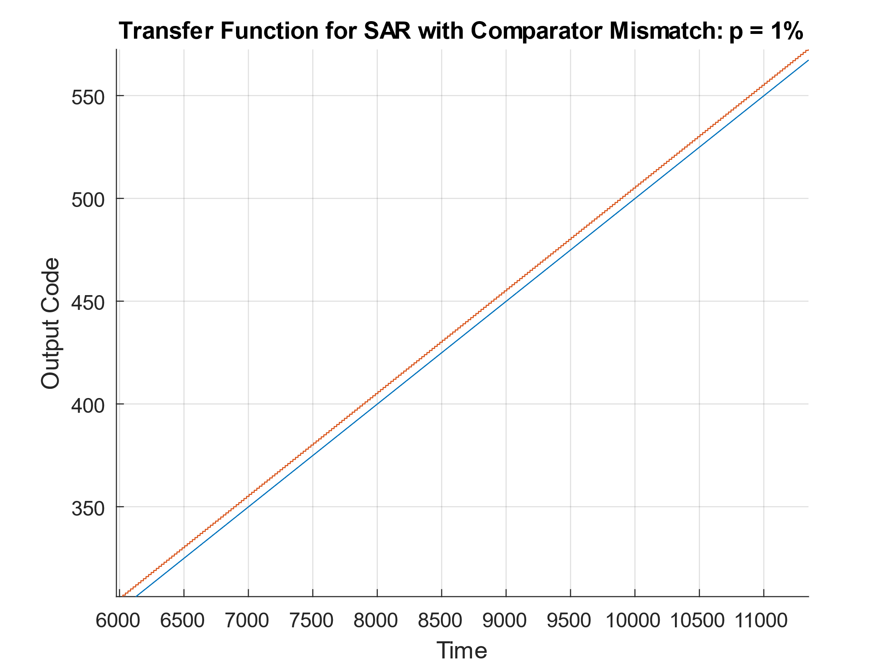We can see that with increased comparator mismatch the DNL is mostly unnaffected except for the lower end of the range. The INL initially shows poor performance, however, this large offset is all due to the initial few DNL output codes. Taking a closer look at the transfer function, shown on the right, we can see that the output codes are smooth and linear, but have an offset due to the comparator mismatch. Since the error in the output code is mostly constant across the entire range, this is an error that can be accounted for on the digital side. The only major issue is the reduced accuracy around the maximum values, GND and VRef.

Spectrum

Introducing comparator mismatch has very little effect on the Spectrum, SNR and ENOB values. MORE MORE MORE MORE

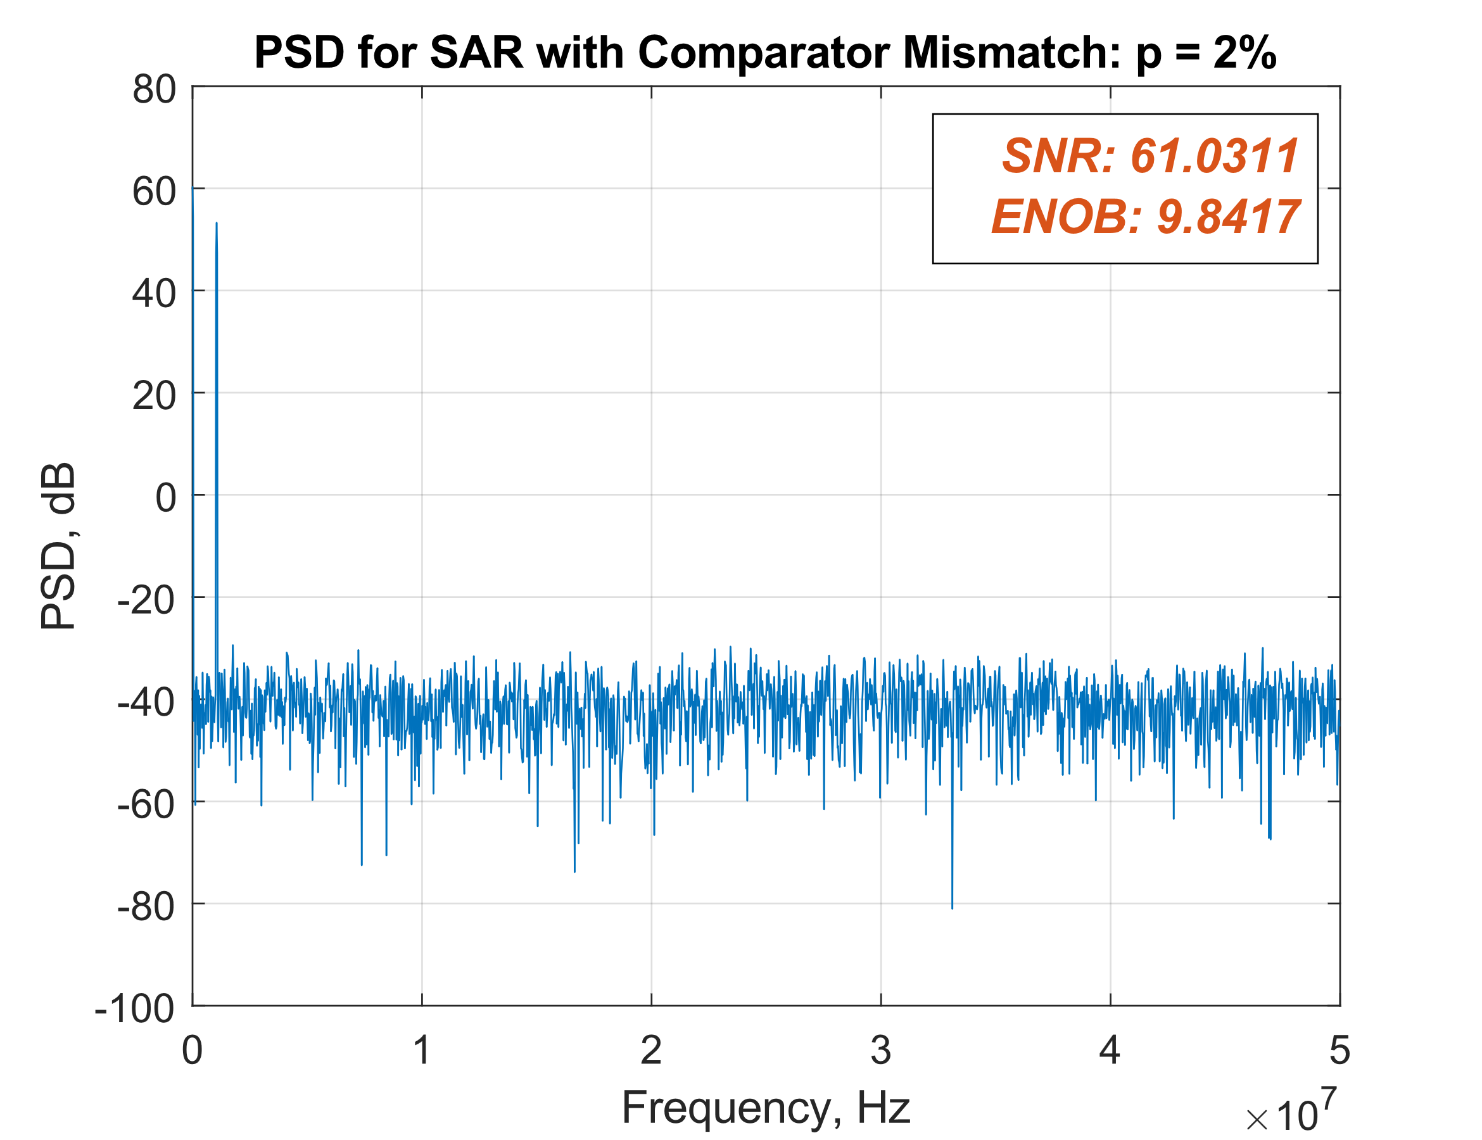

## Question iv)